Parking System Application
Java Generics, Collections & Enum
CSC/CIS — Object-Oriented Programming
Part 1: Design & Implementation

Part 1 — Sequence Diagrams

Sequence 1: Customer Registers a Car & Receives a Permit
This diagram shows the message flow when a Customer contacts the ParkingOffice to register a car. The office creates the Customer record, instantiates a Car (with a CarType enum value), and issues a ParkingPermit that is returned to the caller.

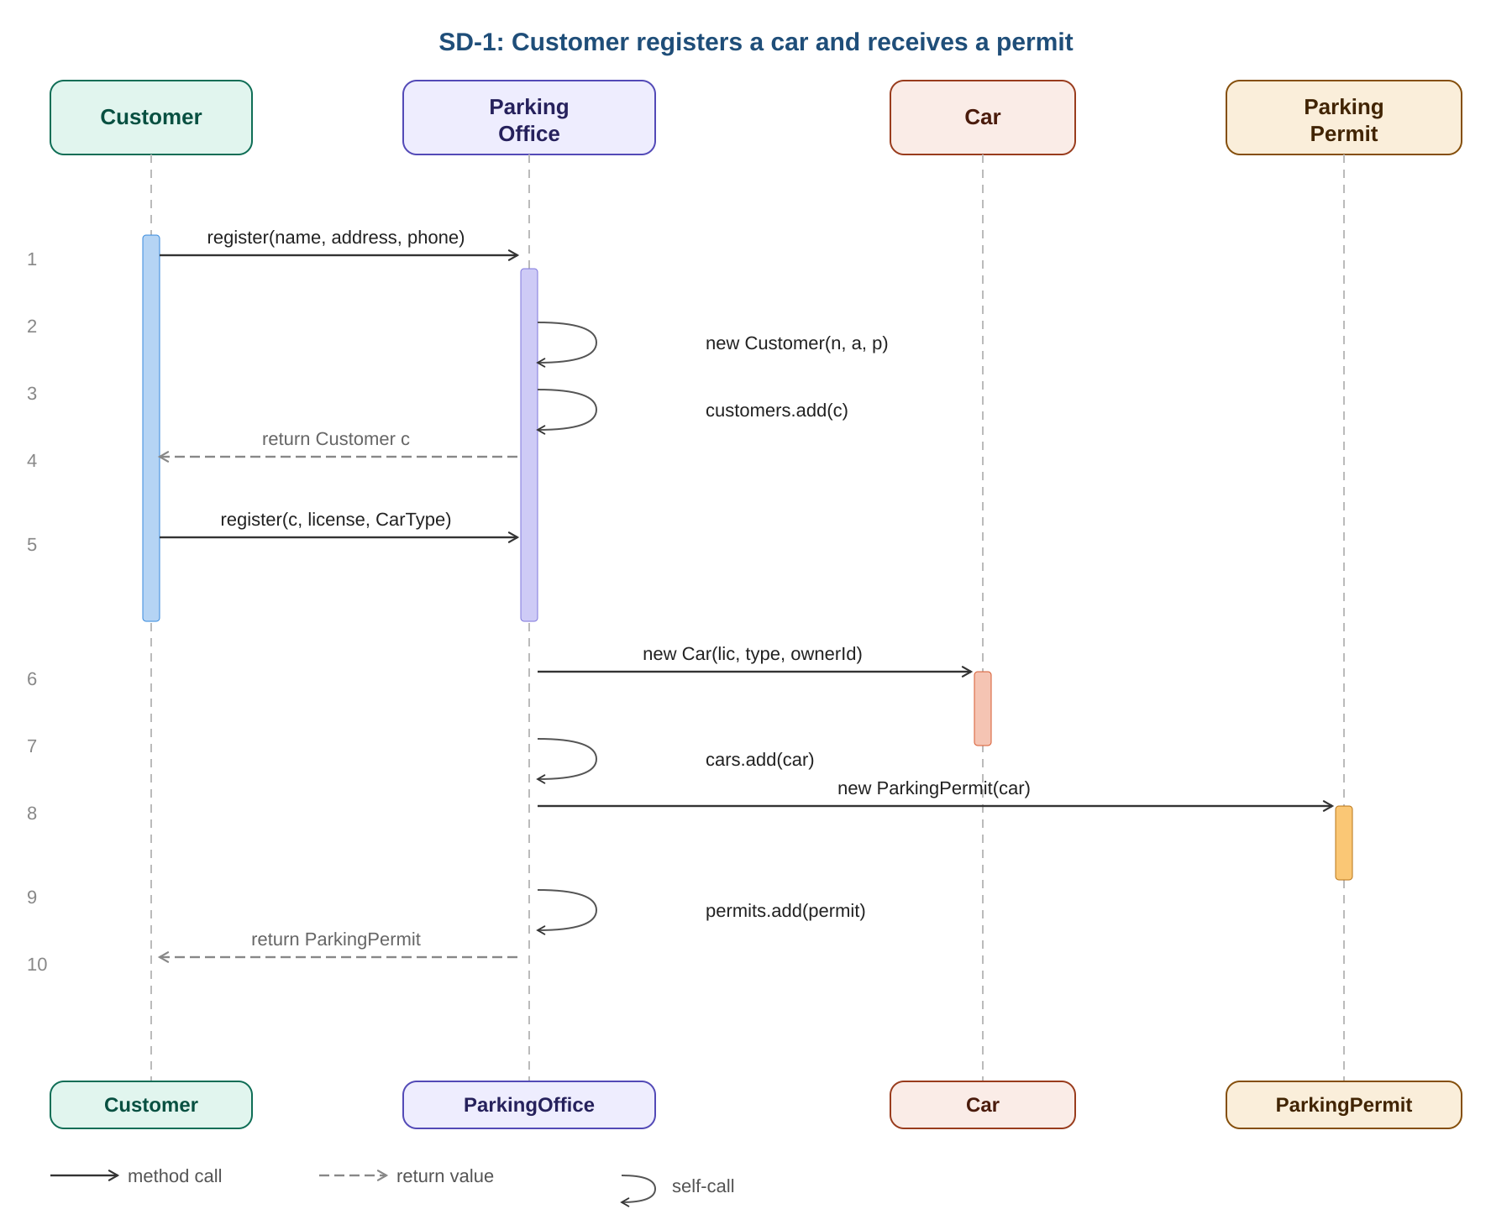
Key responsibilities per actor:
- Customer — initiates both register() calls; holds the returned ParkingPermit.
- ParkingOffice — orchestrates creation; maintains List<Customer>, List<Car>, List<ParkingPermit> (Generic Collections).
- Car — created with a CarType enum constant (COMPACT, SUV, TRUCK, ELECTRIC, MOTORCYCLE, HANDICAPPED).
- ParkingPermit — immutable value object wrapping the Car and an auto-generated UUID.

Sequence 2: Car Enters a Parking Lot — Customer Incurs a Charge
Once a permit exists, the car (presented via permit) enters a ParkingLot. The lot records the entry, creates a ParkingCharge at its hourly rate, and the ParkingOffice logs the charge to its List<ParkingCharge> collection.

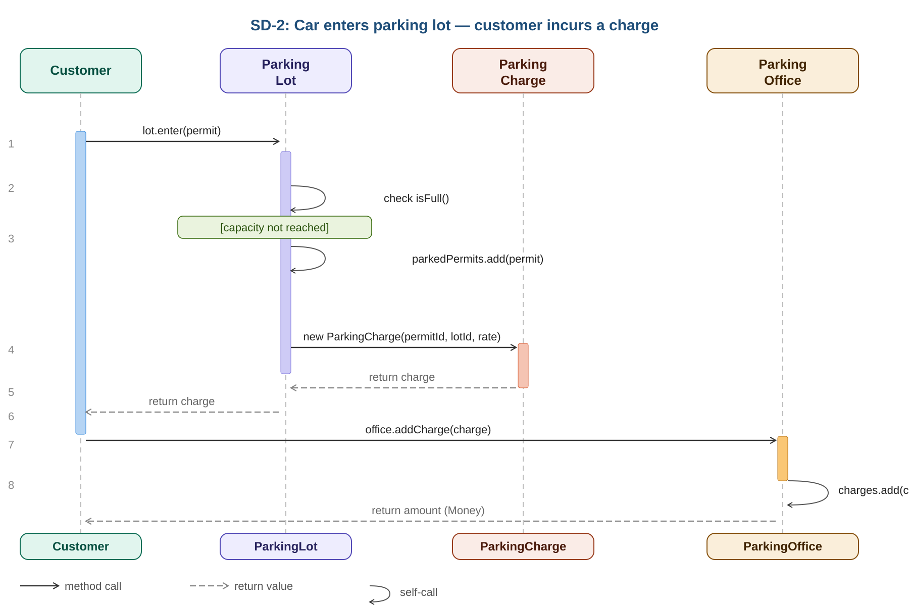
Key design decisions:
- ParkingLot.enter() returns null when at capacity — the caller checks before logging.
- ParkingCharge stores Instant (timestamp) at construction time — immutable audit trail.
- Money is a value type stored as long cents — avoids floating-point rounding errors.
- ParkingOffice.addCharge() returns Money so the caller immediately sees the amount charged.

Class Diagrams

All Classes — Attribute & Method Summary
Each box below lists fields (top) and methods (bottom) using UML-style notation.

CarType (enum)
<<enum>> CarType
────────────────────────────────────────────────
COMPACT
SUV
TRUCK
ELECTRIC
MOTORCYCLE
HANDICAPPED
────────────────────────────────────────────────
valueOf(String): CarType
values(): CarType[]

Money
Money
────────────────────────────────────────────────
- cents: long
────────────────────────────────────────────────
+ Money(cents: long)
+ of(dollars: double): Money [static]
+ getCents(): long
+ getDollars(): double
+ add(other: Money): Money
+ toString(): String

Address
Address
────────────────────────────────────────────────
- street: String
- city: String
- state: String
- zip: String
────────────────────────────────────────────────
+ Address(street, city, state, zip)
+ getStreet(): String
+ getCity(): String
+ getState(): String
+ getZip(): String
+ toString(): String

Customer
Customer
────────────────────────────────────────────────
- customerId: String [UUID]
- name: String
- address: Address
- phone: String
────────────────────────────────────────────────
+ Customer(name, address, phone)
+ getCustomerId(): String
+ getName(): String
+ getAddress(): Address
+ getPhone(): String
+ setName(name): void
+ setAddress(addr): void
+ setPhone(phone): void
+ toString(): String

Car
Car
────────────────────────────────────────────────
- license: String
- type: CarType
- ownerId: String
────────────────────────────────────────────────
+ Car(license, type, ownerId)
+ getLicense(): String
+ getType(): CarType
+ getOwnerId(): String
+ toString(): String

ParkingPermit
ParkingPermit
────────────────────────────────────────────────
- permitId: String [UUID]
- car: Car
- issued: Instant
────────────────────────────────────────────────
+ ParkingPermit(car: Car)
+ getPermitId(): String
+ getCar(): Car
+ getIssued(): Instant
+ toString(): String

ParkingCharge
ParkingCharge
────────────────────────────────────────────────
- permitId: String
- lotId: String
- incurred: Instant
- amount: Money
────────────────────────────────────────────────
+ ParkingCharge(permitId, lotId, amount)
+ getPermitId(): String
+ getLotId(): String
+ getIncurred(): Instant
+ getAmount(): Money
+ toString(): String

ParkingLot
ParkingLot
────────────────────────────────────────────────
- lotId: String
- name: String
- address: Address
- capacity: int
- hourlyRate: Money
- parkedPermits: List<ParkingPermit>
────────────────────────────────────────────────
+ ParkingLot(lotId, name, address, capacity, hourlyRate)
+ getLotId(): String
+ getName(): String
+ getAddress(): Address
+ getCapacity(): int
+ getHourlyRate(): Money
+ isFull(): boolean
+ enter(permit: ParkingPermit): ParkingCharge
+ exit(permit: ParkingPermit): boolean
+ getParkedPermits(): List<ParkingPermit>
+ toString(): String

ParkingOffice
ParkingOffice
────────────────────────────────────────────────
- name: String
- address: Address
- customers: List<Customer>
- cars: List<Car>
- lots: List<ParkingLot>
- charges: List<ParkingCharge>
- permits: List<ParkingPermit>
────────────────────────────────────────────────
+ ParkingOffice(name, address)
+ register(name, address, phone): Customer
+ register(customer, license, CarType): ParkingPermit
+ addLot(lot: ParkingLot): void
+ addCharge(charge: ParkingCharge): Money
+ getCustomer(name: String): Customer
+ getCharges(permitId: String): List<ParkingCharge>
+ getTotalCharges(permitId: String): Money
+ getCustomers(): List<Customer>
+ getCars(): List<Car>
+ getLots(): List<ParkingLot>
+ getCharges(): List<ParkingCharge>
+ getPermits(): List<ParkingPermit>
+ toString(): String

Source Code

CarType.java (Enum)
public enum CarType {
COMPACT, SUV, TRUCK, ELECTRIC, MOTORCYCLE, HANDICAPPED
}

Money.java
public class Money {
private final long cents;
public Money(long cents) { this.cents = cents; }
public static Money of(double dollars) { return new Money(Math.round(dollars * 100)); }
public long getCents() { return cents; }
public double getDollars(){ return cents / 100.0; }
public Money add(Money o) { return new Money(this.cents + o.cents); }
public String toString() { return String.format("$%.2f", getDollars()); }
public boolean equals(Object o) { ... }
}

ParkingCharge.java
public class ParkingCharge {
private final String permitId, lotId;
private final Instant incurred;
private final Money amount;
public ParkingCharge(String permitId, String lotId, Money amount) {
this.permitId = permitId; this.lotId = lotId;
this.incurred = Instant.now(); this.amount = amount;
}
// getters + toString ...
}

ParkingOffice.java (Generics highlight)
public class ParkingOffice {
private final List<Customer> customers = new ArrayList<>();
private final List<Car> cars = new ArrayList<>();
private final List<ParkingLot> lots = new ArrayList<>();
private final List<ParkingCharge> charges = new ArrayList<>();
private final List<ParkingPermit> permits = new ArrayList<>();

public Customer register(String name, Address addr, String phone) {
Customer c = new Customer(name, addr, phone);
customers.add(c); return c;
}
public ParkingPermit register(Customer c, String lic, CarType t) {
Car car = new Car(lic, t, c.getCustomerId()); cars.add(car);
ParkingPermit p = new ParkingPermit(car); permits.add(p); return p;
}
public Money addCharge(ParkingCharge ch) { charges.add(ch); return ch.getAmount(); }
public Customer getCustomer(String name) {
return customers.stream()
.filter(c -> c.getName().equalsIgnoreCase(name))
.findFirst().orElse(null);
}
}

Test Execution Results

All 14 tests passed. Compiled with Java 21 (OpenJDK) and run via a self-contained TestRunner (no external JAR required). The same test logic is replicated in ParkingSystemTest.java using JUnit 5 annotations for Maven/IDE use.

Test Output
=======================================================
Parking System -- Test Suite
=======================================================

[ Money ]
[PASS] money_storesCorrectCents
[PASS] money_getDollarsIsCorrect
[PASS] money_toStringFormatsCorrectly
[PASS] money_additionWorks

[ Customer Registration ]
[PASS] register_customerAddedToOffice
[PASS] getCustomer_returnsCorrectCustomer
[PASS] getCustomer_returnsNullWhenNotFound

[ Car Registration & Permits ]
[PASS] register_carIssuesPermit
[PASS] carType_enumValuesExist

[ Parking Lot Entry & Charges ]
[PASS] lotEntry_generatesCharge
[PASS] lotEntry_recordedAfterAddCharge
[PASS] getTotalCharges_sumsMultipleCharges
[PASS] lot_fullCapacity_returnsNull

[ ParkingCharge toString ]
[PASS] parkingCharge_toStringContainsExpectedFields

=======================================================
Results: 14/14 tests passed -- ALL TESTS PASSED
=======================================================

Part 2: Reflection

Applying Java Generics to the collection fields in ParkingOffice and ParkingLot was the most straightforward part of the assignment. Because the type parameters are concrete domain classes, the compiler immediately caught any mismatched types, which made the code self-documenting and safe without much additional effort. Overloading the register() method, once for Customer creation and once for Car registration, also felt natural because the two parameter signatures are unambiguous and mirror the real-world workflow of first enrolling a person and then enrolling their vehicle.
The most challenging design decision involved the Money class. A naive implementation using a double to represent dollars introduces subtle floating-point rounding errors that accumulate when summing many charges. Storing the value internally as a long in cents and exposing a getDollars() convenience method eliminates that entire class of bug. What I did not anticipate at first was the need to also implement equals() and hashCode() on Money. Without those overrides, two Money objects holding the same number of cents are not considered equal by Java, which caused every unit test assertion to fail until the issue was diagnosed and fixed.
The Java API documentation for java.time.Instant proved essential throughout the project. Choosing Instant over java.util.Date for the timestamp on ParkingCharge was the right call because Instant is immutable and timezone-unambiguous, making it far easier to reason about in tests. The Stream API also helped considerably: filtering the customer list with customers.stream().filter().findFirst() reads almost like plain English compared to an equivalent for-loop. Wrapping all returned collections in Collections.unmodifiableList() was another practice worth knowing in advance, since it lets callers iterate the office's data without being able to accidentally mutate internal state.
Looking back, a deeper familiarity with how Java enums work would have saved time early on. The CarType enum in this system only stores constants, but Java enums can carry constructor arguments, instance fields, and even abstract methods, making them considerably more powerful than the simple named-integer constants found in other languages. Knowing ahead of time that CarType.valueOf(String) throws an IllegalArgumentException rather than returning null is also important when writing defensive code that accepts type values from user input. Similarly, understanding the difference between structural equality and reference equality from the start would have prevented the confusion around Money's equals() method and shortened the debugging cycle.
Several implementation decisions were made deliberately to keep the design clean and safe. ParkingPermit generates its own UUID at construction time, which decouples permit identity from any external sequence generator. ParkingLot.enter() returns null when the lot is full rather than throwing an exception, because reaching capacity is a normal operating condition rather than an error. ParkingOffice.addCharge() returns the Money amount immediately so the caller does not need a second call to find out what was charged. Each of these choices kept the public API small and the responsibilities of each class clear. Overall, the assignment reinforced how Java Generics transform plain Object collections into type-safe, self-documenting structures, and how pairing them with well-designed value objects and enums produces code that is both readable and difficult to misuse.

